**TITLE: - MID POINT CIRCLE GENERATING ALGORITHM**

**OBJECTIVE: -**

* To implement Mid-point circle generating Algorithm

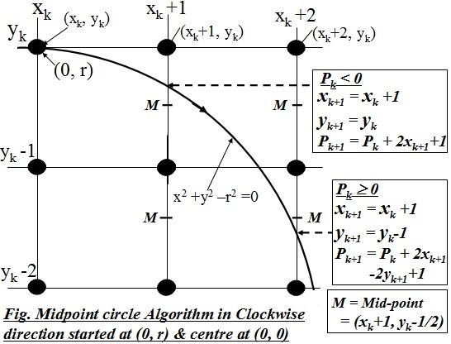**THEORY: -**

The mid-point circle generating algorithm is an algorithm used to determine the points needed for rasterizing a circle. Since, circle is symmetric about its centre; using this algorithm the circumference points in the first octant are calculated. The points in remaining octants are obtained by symmetry.

To implement the mid-point method, we define a circle function as:

$$f_{circle}\left(x,y\right)=x^{2}+y^{2}-r^{2}$$

The relative position of any point $(x,y)$ can be determined by checking the circle function as:

$$f_{circle} (x,y)=\left\{\begin{aligned} >0, & \left(x,y\right) is outside the boundary of curve. \\ =0, & \left(x,y\right) is on the boundary of curve. \\ <0, \left(x,y\right) is inside the boundary of curve. \end{aligned}\right.$$

Suppose, ${(x}_{k},y_{k})$ is the pixel plotted, the next pixel ${(x}_{k+1},y_{k+1})$ will be either ${(x}_{k+1},y_{k})$ or ${(x}_{k+1},y_{k-1})$ as shown in the figure. And, the mid-point is ${(x}_{k}+1,y_{k}-\frac{1}{2})$.

Thus, our decision parameter $P_{k}=f_{circle} {(x}_{k}+1,y_{k}-\frac{1}{2})$

* ${\left(x_{k}+1\right)}^{2}+{\left(y_{k}-\frac{1}{2}\right)}^{2}-r^{2}$…………………………….…….{1}

Also the successive decision parameters are obtained using the incremental calculations. We obtain a recursive expression for the next decision parameter by evaluating the circle function at sampling position $x_{k+1}+1=x_{k}+2$.

Thus, the next pixel to plot will either be $\left(x_{k+1}+1,y_{k+1}\right)$ or $(x_{k+1}+1, y_{k+1}-1)$.

Also, the mid-point is: ${(x}_{k}+1,y_{k}-\frac{1}{2})$ and thus, our decision parameter $P_{k+1}={(x}_{k+1}+1,y_{k+1}-\frac{1}{2})$

$P_{k+1}={({(x}_{k}+1)+1)}^{2}+{\left(y_{k+1}-\frac{1}{2}\right)}^{2}-r^{2}$

* $P_{k+1}={\left(x_{k}+1\right)}^{2}+2\left(x_{k}+1\right)+1+{\left(y_{k+1}-\frac{1}{2}\right)}^{2}-r^{2}$…… {2}

Now, subtracting {1} from {2}, we get;

$P_{k+1}-P_{k}=2\left(x_{k}+1\right)+\left(y_{k+1}^{2}-y_{k}^{2}\right)-\left(y_{k+1}-y_{k}\right)+1$

If, $P_{k}<0$, the mid-point is inside the circle and the pixel on the scan line $y_{k}$ closer to the circle boundary. Otherwise, the mid-point is outside or on the boundary and we select the pixel on scan line $y_{k+1}$.

**CASE I: $P_{k}<0$**

$x_{k+1}=x_{k}+1$

$y_{k+1}=y_{k}+1$

$P_{k+1}=P_{k}+2x_{k+1}+1$

**CASE II : $P_{k}>0$**

$x_{k+1}=x_{k}+1$

$y_{k+1}=y_{k}-1$

$P_{k+1}=P_{k}+2x_{k+1}-2y_{k+1}+1$

For Initial decision parameter, our starting point is $(0,r)$ at the top, then the initial decision parameter is obtained by evaluating the circle at starting position $\left(x_{o}, y_{o}\right).$

$P_{o}=f_{circle}\left(0,r\right)$

$P_{o}={\left(x_{o}+1\right)}^{2}+{\left(y_{o}-\frac{1}{2}\right)}^{2}-r^{2}$

$P_{o}={\left(0+1\right)}^{2}+{\left(r-\frac{1}{2}\right)}^{2}-r^{2}$

$P_{o}=1+r^{2}-r+\frac{1}{4}-r^{2}$

$P_{o}=\frac{5}{4}-5$

* $P_{o}=1-r$**(eqvt.)**

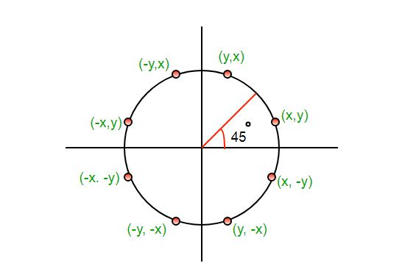

**Mid-Point Circle Drawing Algorithm $(o,r)$:**

Step 1: Input radius $r$ and circle centre $(x_{c},y_{c})$ and obtain the first point on the circumference of a circle centred on the origin as $\left(x_{o},y_{o}\right)=(0,r)$.

Step 2: Calculate the value of initial decision parameter as $P_{o}=1-r$.

Step 3: At each $x_{k}$ position, starting at $k=0$, perform following tasks:

1. If $P_{k}<0$, next point along the circle centred at origin is $(x_{k}+1,y_{k})$ and $P_{k+1}=P_{k}+2x_{k+1}+1$.
2. Else, the next point is $(x_{k}+1,y_{k}-1)$ and $P_{k+1}=P_{k}+2x_{k+1}-2y_{k+1}+1$.

Step 4: Determine the symmetry points on the 7 octants.

Step 5: Move each calculated pixels position $(x,y)$ onto the circular path centred on $(x_{c},y_{c})$ and plot the coordinate values as $x=x+x_{c}$ and $y=y+y_{c}$.

Step 6: Repeat step 3 through Step 5 until $x≥y$.

Note: For the circle starting from $(r,0)$, $y_{k+1}=y_{k}+1$ but $x_{k+1}=x_{k} or x_{k}-1$ and the operations are performed accordingly.

**Some advantages of Mid-point Circle Drawing Algorithm:**

* Can be extended to draw ellipse.
* Non-floating Point arithmetic
* More efficient compared to other algorithms.
* Does not requires extensive memory usage.
* Relatively easy to understand and implement.

**Some Disadvantages of Mid-Point Circle Drawing Algorithm:**

* Jagged edges and distortion in the appearance of the circle.
* Just draw the circle outline. Does not support filling circle.
* Rounding floating points gives certain inaccuracies.
* Limitedly efficient for modern hardware.
* Needs extra consideration for off-centre circle and ellipse drawing.

**Program to implement Mid-Point Circle Generating Algorithm:**

#include <iostream>

#include <stdio.h>

#include <conio.h>

#include <graphics.h>

using namespace std;

void print_points(int x, int y){

char p1[15];

sprintf(p1,"(%d, %d)",x,y);

outtextxy(x,y,p1);

}

int main(){

int r, x1, y1, xk, yk, pk;

cout << "Enter the radius of the circle:- ";

cin >> r;

cout << "Enter the center:- ";

cin >> x1>> y1;

xk = 0;

yk = r;

pk = 1 - r;

int k = 0;

initwindow(getmaxwidth(), getmaxheight(),"MID POINT CIRCLE ALGORITHM");

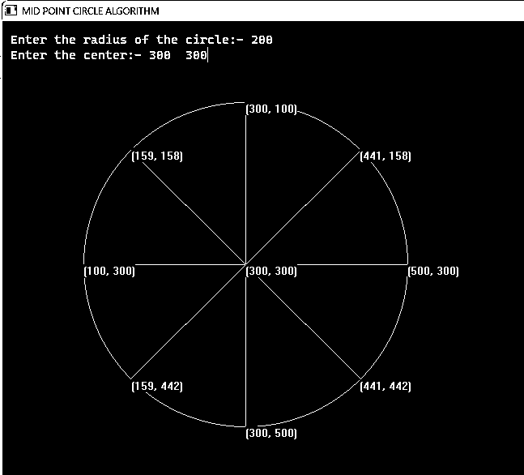 do{

putpixel(xk + x1, yk + y1, 15);

putpixel(yk + x1, xk + y1, 2);

putpixel(-xk + x1, yk + y1, 3);

putpixel(-yk + x1, xk + y1, 5);

putpixel(xk + x1, -yk + y1, 7);

putpixel(yk + x1, -xk + y1, 8);

putpixel(-xk + x1, -yk + y1, 4);

putpixel(-yk + x1, -xk + y1, 6);

if (pk < 0){

xk = xk + 1;

yk = yk;

pk = pk + 2 * xk + 1;

}

else{

xk = xk + 1;

yk = yk - 1;

pk = pk + 2 * xk + 1 - 2 * yk;

}

k++;

}

while (xk <= yk);

line(x1 - xk, y1 - yk, xk + x1, yk + y1);

line(x1 - xk, y1 + yk, xk + x1, -yk + y1);

line(x1, r + y1, x1, y1 - r);

line(x1 - r, y1, x1 + r, y1);

print_points(-r+x1, y1);

print_points(yk + x1, -xk + y1);

print_points(x1+r, y1);

print_points(-yk + x1, -xk + y1);

print_points(x1, -r + y1);

print_points(yk + x1, xk + y1);

print_points(x1, r + y1);

print_points(-yk + x1, xk + y1);

print_points(x1,y1);

getch();

closegraph();

}

**CONCLUSION**:

In this way, we implement Mid-point circle generating algorithm through writing code in C++ programming language and analysed its precision and way of calculation.